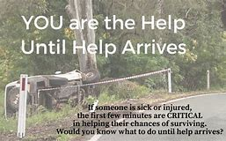

Westford Health Department
YOU ARE THE HELP, UNTIL HELP ARRIVES, IS A TRAINING THAT PROVIDES INFORMATION ON HOW TO SAVE A LIFE. THERE ARE FIVE ESSENTIAL ACTIONS: 1. CALL 911, 2. STAY SAFE, 3. STOP THE BLEEDING, 4. POSITION THE INJURED, AND 5. PROVIDE COMFORT. IF YOU WISH TO LEARN LIFE SAVING SKILLS, PLEASE ATTEND THIS TRAINING.
DATE: Tuesday, December 19, 2023
TIME: 6:00 PM to 9:00 PM
LOCATION: Westford Town Hall, 55 Main Street, second floor meeting room
RSVP: Friday, December 15, 2023, by emailing
Mandy Vozzo Willis mvozzowillis@westfordma.gov

MAX of 18 participants

