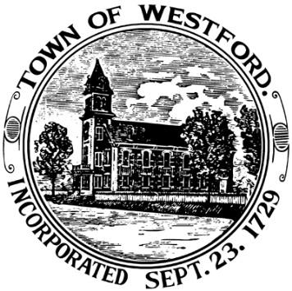

12 NORTH MAIN STREET TASK FORCE
MEETING POSTING & AGENDA
January 14, 2021 at 2:00 PM
Virtual Public Meeting – See Link Below

2:00PM - Assign recorder of minutes

2:02PM – Receive contract award recommendation from the RFP Review Group for the bid #21-17 Disposition of 12 North Main Street

2:15PM – Discuss recommendation provided and vote on task force recommendation to the Select Board to consider

3:00PM - Adjourn meeting

Instructions to access the meeting remotely:

Please join my meeting from your computer, tablet or smartphone.
https://global.gotomeeting.com/join/164358605
You can also dial in using your phone.
United States: +1 (571) 317-3122
Access Code: 164-358-605

